Name:_________________________________________ Period:__________

Pregnancy Packet

Section I: Signs of Pregnancy: Fill in the Blank. Use the words listed to fill in all of the blanks to make each sentence make sense. Each word is only used once.

HCG Tiredness Late Urination Appetite
Shorter Vomiting Size Tenderness Urine

1. Period is ______________________________ or missed.

2. Abnormal period, lighter or __________________________ than usual.

3. Breast ______________________________ or fullness.

4. Nausea and sometimes ______________________________.

5. Changes in ______________________________.

6. Frequent ______________________________.

7. Fatigue or ______________________________.

8. Urine Test is used to detect the presence of ______________________________, a hormone that is produced when a women is pregnant.

9. Pelvic Exam is used to check the ______________________________ of the uterus.

10. Blood Test is rarely used because ______________________________test are simpler to use and just as accurate.

Section II: Order of events in fetal Development: Place a number on the line in the order you think the events occur

11. _______ Cells begin to divide
12. _______ Fertilized egg implants into
uterus wall
13._______ Cervix dilates
14. ______ Pregnancy is full term baby turns head down
15._______ Gender can be seen
16._______ Fetus can hear
17._______ Sperm cell enters egg
18_______ All organs can function
19_______ Heart begins to beat
20._______ Hands and feet develop

Section III: Order of Development: Place these baby names in the order in which they occur during pregnancy by writing the number under each name. 1 being the first to occur and 5 being the last to occur.

A. Baby B. Blastocyst C. Zygote D. Embryo E. Fetus
22. _______ 23. _______ 24._______ 25._______ 26._______

Section IV: Terms during pregnancy: Place the Terms with the correct definition for pregnancy.

Amniotic Sac
Placenta

Umbilical Chord
Vernix
Crowning Lanugo
27. __________________Supplies fetus with oxygen, supplies fetus with nutrients, and passes out wastes from the fetus.

28. ________________ Is a rope like structure that connects the embryo to the placenta. It has 1 large vein, and 2 arteries.

29. _________________ Acts as temperature control, protection from shock, barrier to infection.

30. _________________ Is fine downy hair that covers the fetus to help insulate, and regulate body temperature.

31. _________________ Is white, cheese-like substance that acts like a waterproof barrier against the amniotic fluid.

32. _________________ Is the appearance of the baby’s head during delivery.

Section V: Order Signs of Labor and Stages of Birth: Place the stages of birth in the order in which they occur during pregnancy. 1 is the first to occur and 6 the last to occur.
Birth of Baby The Show Birth of placenta 33. _______ 34._______ 35._______
Water Breaks Contractions Dilation of cervix
36. _______ 37._______ 38._______
Section VI: Match the correct type of pregnancy to the definition:
A. Medication given or water sac broken by plastic hook (amnio-hook)

B. A shot administered in the woman’s lower back to aid in pain relief.

C. A form of childbirth in which a surgical incision is made through a mother's abdomen and uterus to deliver one or more babies.

D. When baby delivered either foot first or buttocks first.

E. Delivery of a baby without using drugs or surgery during birth.

F. An incision between the vagina and anus (perineum) help with crowning of the baby, to prevent muscles from tearing

G. Assist mother if she becomes too tired, cup on baby’s head with slight suction

H. Guide baby’s head out of birth canal

39. Natural Birth _______

40. Induced Labor _______

41. Breech Birth _______

42. Cesarean Section _______

43. Epidural_______

44. Episiotomy_______

45. Vacuum Extraction _______

46. Forceps_______

Section VII: Match the correct pregnancy terms to the definition:
A. Test using sound waves to depict an image of the developing fetus

B. New DNA test that measures for Down Syndrome

C. Prenatal test where amniotic fluid is removed for testing

D. Procedure that involves removing a living egg from a female, inseminating the egg with a donor sperm and returning the fertilized egg back into the woman

E. Sperm is injected into the female with a syringe

F. Drinking alcohol during pregnancy can cause this

G. Breathing method used during the delivery process to redirect the focus from pain

H. Is an assessment test on a scale 1-10, which is performed after baby it born.

47. Apgar Scale _______

48. Lamaze_______

49. FAS_______

50. In-Vitro _______

51. Artificial Insemination _______

52. Harmony_______

53. Amniocentesis_______

54. Ultrasound______
Section VIII: Place the pictures in order from day one to delivery. Include trimester next to picture
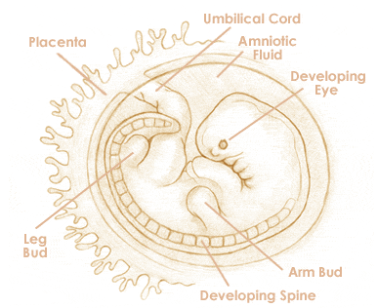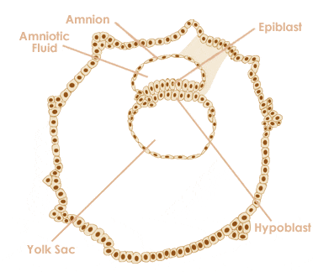

55. ___________________________________________ 56.___________________________________________

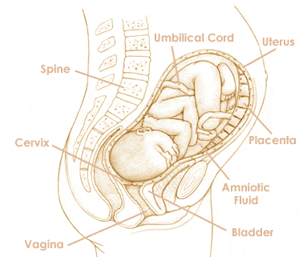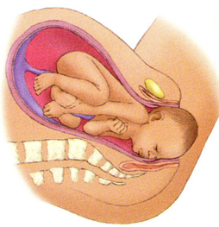

57. ___________________________________________ 58.___________________________________________

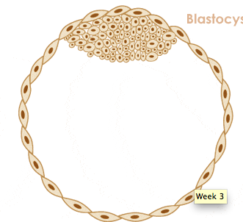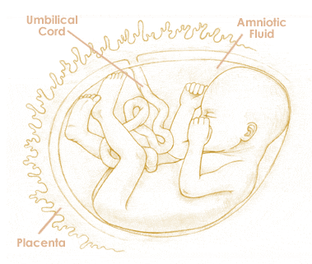

59. ___________________________________________ 60.____________________________________________

